
Crisis Communication Plan
University of Phoenix
Bad News Bears
Aliana Head, Amery Saldaña, Constance Barber, Kaitlyn Wynn
December 12, 2022

Table of Contents
Introduction . . . . . . . . . . . . . . . . . . . . . . . . . . . . . . . . . . . . . . . . . . . . . . . . . . . . . . . . . . . . . . . . 3
Statement from Management to Employees . . . . . . . . . . . . . . . . . . . . . . . . . . . . . . . . . . . . . . . 4
Definitions . . . . . . . . . . . . . . . . . . . . . . . . . . . . . . . . . . . . . . . . . . . . . . . . . . . . . . . . . . . . . . . . . 6
Crisis Inventory . . . . . . . . . . . . . . . . . . . . . . . . . . . . . . . . . . . . . . . . . . . . . . . . . . . . . . . . . . . . . 7
Warning Signs of crisis. . . . . . . . . . . . . . . . . . . . . . . . . . . . . . . . . . . . . . . . . . . . . . . . . . . . . . . . 9
List of Key Publics/Audiences . . . . . . . . . . . . . . . . . . . . . . . . . . . . . . . . . . . . . . . . . . . . . . . . . 12
Methods of communication . . . . . . . . . . . . . . . . . . . . . . . . . . . . . . . . . . . . . . . . . . . . . . . . . . . . 14
Communication procedure for minor crisis . . . . . . . . . . . . . . . . . . . . . . . . . . . . . . . . . . . . . . . . 17
Communication procedure for major crisis. . . . . . . . . . . . . . . . . . . . . . . . . . . . . . . . . . . . . . . .. 18
Emergency Operations Center . . . . . . . . . . . . . . . . . . . . . . . . . . . . . . . . . . . . . . . . . . . . . . . . . 20
The Crisis Team & Communication Chain. . . . . . . . . . . . . . . . . . . . . . . . . . . . . . . .. . . . . . . . . 21
Crisis Directory/Contact List . . . . . . . . . . . . . . . . . . . . . . . .. . . . . . . . . . . . . . . . . .. . . . . . . . . 22
Crisis Management Plan. . . . . . . . . . . . . . . . . . . . … … . . . . . . . . . . . . . . . . . . .. . . . . .. . . . . . 23
Identification of a Spokesperson. . . . . . . . . . . . . . . . . . . . . . . . . . . . . . . . . . . .. . . . . .. . . . . . . 28
Guidelines for Spokespeople. . . . . . . . . .. . . . . . . . . . . . . . . . . . . . . . . . . . . . . . . . . . . . . . . . . 30
Example of Initial Statement for Release. . . . . . . . . . . . . . . . . . . . . . . . . . . . . . . . . . . . . . . . . . .32
News Release . . . . . . . . . . . . . . . . . . . . . . . . . . . . . . . . . . . . . . . . . . . . . . . . . . . . . . . . . . . . . . . 33
Background statement . . . . . . . . . . . . . . . . . . . . . . . . . . . . . . . . . . . . . . . . . . . . . . . . . . . . . . . . 36
Fact sheet. . . . . . . . . . . . . . . . . . . . . . . . . . . . . . . . . . . . . . . . . . . . . . . . . . . . . . . . . . . . . . . . . . . 37
Sample Letter to Stakeholders . . . . . . . . . . . . . . . . . . . . . . . . . . . . . . . . . . . . . . . . . . . . . . . . . . 38
Website . . . . . . . . . . . . . . . . . . . . . . . . . . . . . . . . . . . . . . . . . . . . . . . . . . . . . . . . . . . . . . . . . . . . 41
Social Media . . . . . . . . . . . . . . . . . . . . . . . . . . . . . . . . . . . . . . . . . . . . . . . . . . . . . . . . . . . . . . . . 43
Messages for the News Media During Unforeseeable Technical Interaction Crises . . . . . . . . .45
Messages for the News Media During Hacking Crises . . . . . . . . . . . . . . . . . . . . . . . . . . . . . . . 46
Messages for the News Media During Cheating and Plagiarism Crises . . . . . . . . . . . . . . . . . . 47
Possible Questions and Suggested Responses . . . . . . . . . . . . . . . . . . . . . . . . . . . . . . . . . . . . . .49
Pre Gathered Information . . . . . . . . . . . . . . . . . . . . . . . . . . . . . . . . . . . . . . . . . . . . . . . . . . . . . .55
URLs for Resources . . . . . . . . . . . . . . . . . . . . . . . . . . . . . . . . . . . . . . . . . . . . . . . . . . . . . . . . . . 56
Evaluation of Plan Effectiveness After a Crisis. . . . . . . . . . . . . . . . . . . . . . . . . . . . . . . . . . . . . .58
References . . . . . . . . . . . . . . . . . . . . . . . . . . . . . . . . . . . . . . . . . . . . . . . . . . . . . . . . . . . . . . . . . .60

Introduction
The University of Phoenix proves to provide higher education opportunities to help students achieve their academic goals. With debate and issues surrounding the education realm, it is best advised that The University of Phoenix prepare for the possibilities of damages that have a high potential of ruining the reputation of the foundation. With a good- universal reputation and presence, The University of Phoenix currently remains productive in the education domain. It is crucially important that The University of Phoenix remain in the positive limelight, and the generational reputation is not damaged by any means of preventable action.
The Crisis Communication plan (CCP) is a vital component in the overall safety measures of the University of Phoenix. This CCP is designed to guide the university through a process that supports the preparation of an issue, preventing it from turning into something bigger. While every situation and crisis is unique, having a CCP can effectively manage an emergency crisis. The University of Phoenix must be able to respond in a timely manner, accurately and confidently report information, and reach the various publics and stakeholders to the university. This is done through the crisis communication plan, which proves to be an active component in the risks management of the university.
The crisis communication plan (CCP) is critical in saving the reputation of University of Phoenix, as well as the financial and educational opportunities that are accessible to UoPx. If the CCP is not followed in the event of a crisis, major damages can occur that can result in the loss of trust, recognition, donors and even the overall University. As education, technology and reputation stand as the forefront of importance within the university, students/alumni/employees/members must feel safe in the regards that if a problem does occur, it will be handled in an exemplary fashion and will not reoccur.
Statement from Management
Mission statement: University of Phoenix provides access to higher education opportunities that enable students to develop knowledge and skills necessary to achieve their professional goals, improve the performance of their organizations, and provide leadership and service to their communities.
Reputation: The University of Phoenix wants to offer a safe, trusted and transparent environment for our community to thrive in. Our commitment to the students, staff and faculty, and parents must be unparalleled in maintaining this environment. Each member of our team must be well prepared to handle a crisis to ensure we maintain a level of trust with our community and can continue to educate our students and uphold our mission.
Purpose:
- To facilitate cognitive and effective communication with stakeholders in the event of a crisis.
- To develop competence in communication, critical thinking, collaboration, and information utilization, together with a commitment to lifelong learning for enhancement of students' opportunities for career success.
- To provide instruction for an effective, efficient, and transparent resolution to any crises as well as for after-crises work.
- To ensure our university remains true and dedicated to its commitment to all stakeholders by upholding our mission..
- To maintain strong relations with our stakeholders, even in times of non crisis.
- To be organized as a private institution in order to foster a spirit of innovation that focuses on providing academic quality, service, excellence, and convenience to the working student.
Objectives: Through this plan we hope to quickly and successfully navigate crises, both large and small. We are committed to maintaining transparency, honesty and authenticity through each outcome. Efforts will be made to communicate with our students, employees, management, communities, etc. These efforts will aim to alleviate community and public concerns, minimize media speculation, and ensure trust is kept in our school.

Definitions
Crises
Crises are unplanned events that directly or potentially threaten the company’s
reputation. Events that fall into this category include: fires, explosions, bomb threats, civil disturbances, widespread illness, and other types of incidents.
Minor Crisis
A minor crisis is one that the university would be able to handle quickly without much disturbance. Small issues that arise within a specific department, group or organization that do not concern many other people would fall into this category.
Major Crisis
A major crisis would involve the majority of the school’s population or be a potential threat to the reputation of the university. This would consist of environmental events that put students at risk, the health and safety of our campus and all who are students and faculty, and other incidents that would cause the media and other publics to focus on our university.
Plagiarism
Plagiarism is the act of using work from someone else and passing it off as your own. This can include lack of citations, reusing a student’s work from previous years, and many other examples.
Hacking
Hacking is the act of compromising digital devices such as phones, computers and networks with the intention of accessing private information.

Crisis Inventory
- Three crises that the University of Phoenix might face
  - Unforeseeable Technical Interactions (Likelihood 4, Impact 2)
    - Seeing that the University of Phoenix primarily provides online courses for students to take from their specific location, having reliable technology is vital. Without the university’s platforms working at full capacity, students would be at a disadvantage. All online educational platforms must perform at their optimal level and University of Phoenix must have a plan in place in the case that unforeseeable technical interactions occur.
  - Hacking (Likelihood 3, Impact 4)
    - University’s host their students' private information, financial information and educational assets in secure platforms. The possibility of hacking puts students' information at risk. Assuring students that their information has been properly stored and protected is vital to the security of University of Phoenix. In the case that hacking occurs, University of Phoenix must have a plan in place to keep their students' information and technology safe.
  - Plagiarism (Likelihood 3, Impact 3)
    - Plagiarism is a major concern for any university, but because the University of Phoenix prides itself on providing a fully online educational track for their students, assuring that all work done by students is fact checked and not plagiarized is vital to the success of the university and its assets. Assuring that all students’ work is their own is important for the student themselves, but also the university. All occurrences of plagiarism must be taken seriously and addressed at the highest level, in order to protect individuals’ work and the university’s reputation.
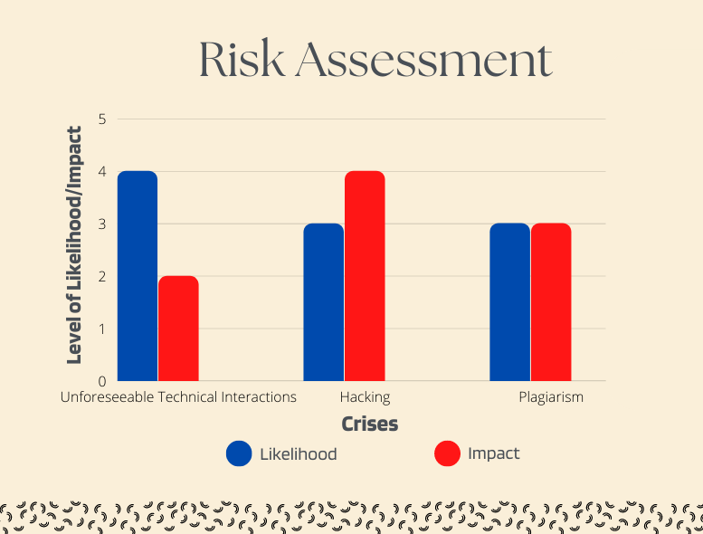

Warning Signs
- Unforeseeable Technical Interactions
  - Unforeseeable technical interactions may be recognized early if the University of Phoenix’s currently adopted student platforms go down. If Canvas is shut down for a prolonged period of time, students will not be able to complete their work and communicate with their professors. If prior contact is not made by the manufacturers of these platforms, the university must react quickly to inform their stakeholders of the shutdown. University of Phoenix might be warned of unforeseeable technical interactions if small IT concerns have been raised (systems lagging, freeze, etc.) Another warning sign of these technical interactions might be if there is a power outage in specific areas where students of the University of Phoenix live. Storms, hurricanes, natural disasters, etc. should be watched closely to ensure preparation for technical interactions.
- Hacking
  - Warning signs of hacking at the University of Phoenix would be if any technical sites had been tampered with (repeated wrong logins, etc.). Another warning sign of hacking would be if there has been an influx in emails or other forms of communication received by students from out-of-university contacts. Redirected Internet searches, fake antivirus messages and unwanted browser toolbars are also signs that a platform has been hacked or is on the verge of hacking.
- Cheating / Plagiarism
  - Warning signs of cheating or plagiarism would be if online platforms similar to Chegg or Quizlet have been accessed during exams, tests or quizzes. If there is inappropriate wordage, uncalled for hyperlinks, or inconsistent spelling and grammar, there is a high chance that work is being plagiarized or a student is cheating. If students are repeatedly submitting work that does not seem truthful to their own self, plagiarism should be taken seriously and analyzed. Inconsistencies in citations and references is also a warning sign of plagiarism in students’ work because by not citing or providing credit, the student is claiming all work to be their own.
Past Issues
- Blackboard Shuts Down on Utah State University
  - In 2007, Utah State University used the platform Blackboard as an online learning tool where professors can upload assignments and grades and students can complete and turn in assignments (Arie, 2007). That year, Blackboard’s database was shut down due to corrupt data. Both students and faculty at USU lost all information uploaded between Tuesday, Nov. 13 and Friday, Nov. 16. The school immediately reached out to Blackboard’s directors to alert them of the issue and get it resolved. The school ensured that no student would be jeopardized for this. Raymond Coward, the executive vice president and provost at the school stated that they will deal with this issue in a way “that is fair for the students and appropriate for the particular situation of each course.”
- Marymount Manhattan College Data Breach
  - On August 3rd, 2022, a data breach was reported to numerous offices of state attorney generals by Marymount Manhattan College (Console, 2022). The college reported that the breach accessed names, drivers license numbers, medical information, financial information, health insurance information and social security numbers of certain individuals. MMC immediately sent word to those whose information was compromised and filed reports with several attorney generals.
The school can be held liable for this data breach and the harm that falls on the victims, if those affected can prove it was a direct result of the school’s negligence. There is not yet information on whether or not any one is pursuing a lawsuit against the school.
- Cheating and Plagiarism Warning Signs with Chegg, Inc.
  - In 2013, the University of Phoenix settled a copyright lawsuit filed against Chegg, Inc (Rogers, 2015). The case stated that Chegg, Inc. violated copyrights on the university’s course material. StudentofFortune.com, a website owned and operated by Chegg, Inc., allows homework questions to be submitted by users, and offers paid tutorials on the subject from experts. Not all of the terms of the settlement were released, however one that was made public was that there would be increased monitoring of sites owned by Chegg, Inc. to ensure the protection of academic content. The University of Phoenix prides itself on the validity of its program and courses. Allowing much of their academic content to be available on the internet would jeopardize the academic integrity of the school and the value of its degree overall.

List of Key Publics/Audiences During a Crisis
- (internal) Board members, donors, investors, current students, staff, faculty, parents, prospective students, executive members
- (external) Competing universities, media, government officials, alumni, surrounding community, legal representation, policy makers
- Our enabling publics are the board members, investors, donors and policy makers of the University of Phoenix.
Our functional publics are the students, staff, faculty, and executive members of the University of Phoenix.
Our normative publics are competing universities, professional organizations, prospective students, and alumni of the University of Phoenix.
Our diffused publics are community groups, legal representation, the media and government officials of the University of Phoenix.
- Key objectives when communicating to each public will result in communication styles that are unique to each public.
For our enabling publics, our objective will focus on addressing the concerns revolving around the logistics behind what happened, and considering how this could financially, perceptually and legally affect the University of Phoenix. We will review how this could negatively impact our board members, investors, donors and policy makers regarding finances, educational quality, integrity, and quality of the organization.
For our functional public, our objective will focus on addressing our internal stakeholders, notifying the public of what happened and expressing concerns about the operations within the organization and how it will affect them. We will consider how this will negatively impact our students, faculty, staff and executive members in terms of reputation, harm and their ability to work in a safe and effective environment.
For our normative publics, our objective will pivot on addressing how the crisis happened, and how the organization will come back from the crisis, and will express concerns on how this will affect public perception of the university. Going back to the University's central mission and vision statement, we will reflect on how the university will provide a long-term solution to the crisis.
For our diffused publics, our objective will focus on addressing a broader audience, answering the questions of how, who, what, when and where, along with providing a plan of action. We will consider how this affects our overall organizational perception, and be transparent with any legality aspects.

Methods of Communication During a Crisis/Notifying Publics
- The notification process for which the University of Phoenix initiates in a crisis will begin when and where the crisis has occurred. The person who originally is the first to discover the incident will call the University’s emergency number, 602-827-2045. The crisis team will then be notified. After evaluating the magnitude of the crisis, the crisis team will notify the crisis directory contact list, which is listed below. From this point and on, notification will continue to occur according to the crisis directory and through various chain-of-command channels.
Once the initial notification occurs, corporate PR officials, executive members and board members will be notified and will follow procedures located below. Notifying the public will occur once everyone who is aware of the Crisis Communication Plan, along with the crisis directory contact. We will objectively address all of our publics through various mediums and chain-of-command channels.
- This list will inform on how each public may potentially receive information about the crisis. This remains important when considering an effective communication process during the emergency at hand.
Board members and executive members:
Direct knowledge of the crisis, organization security, communications team, PR team, personal calls about crisis, social media, and media reports.
Faculty, staff, current students and parents:
Direct knowledge of the crisis, other faculty, staff or students or parents, social media, news media, electronic mail, organization community, word-of-mouth, and the university's statement itself.
Competing universities, Alumni and prospective students:
Social media, news reports, word-of-mouth, students, staff or parents of the university, outside “experts.”
Donors, investors:
Direct knowledge of the crisis, personal calls or notifications, media reports, news reports, staff at the university.
Legal representation, policy makers and government officials:
Legal affairs, government affairs, news media reports, concerned citizens, staff, parents or students, board members, and executive members.
Media and surrounding communities:
PR/Communications team, other news media sources, spokesperson for the university, outside “experts”, eyewitnesses including students, faculty and staff members of the university.
- The following documents are recommended tools that the University of Phoenix use to each communication group that is listed above.
These tools will demonstrate usefulness in documenting information related to incidents and for keeping track of media inquiries:
Emergency response contact directory, Communications/PR team contacts, crisis information sheet, initial release, news conference center checklist, and direct facts of crisis.

Method of communication:
 | News media | Social media | Email | News- letter | News release | Security team | Spokes-person | PR team
Public:
Students, Staff, Faculty
Media Outlet
Board Members
Investors, Donors
Government Officials
Competing Universities
Policy Makers
Legal Representation

Communications Procedure for Handling a Minor Crisis
- The President's office receives notification from the initial crisis discoverer and collects information on the facts of the crisis and chronology of the crisis.
- The President informs the Chief Marketing Officer, who becomes the PR Lead, and all other members on the crisis directory.
- The PR Lead/ Communications team decides whether there is a need for more information or representation at the site of the incident.
- PR Lead contacts the Incident Commander (commander of scene where the incident occurred) and gathers more details about the event. (Specifically who, what, when, where, why, is there a present threat to anyone, etc.)
- On hours, PR Lead connects with PR Manager, the Chief Information Officer. Weekends or off-hours, PR Lead connects with PR Manager and PR Duty Officer, Chief Human Resources Officer, if needed. If the PR Lead thinks media inquiries will be made, the PR Duty Officer must immediately notify the University phone operators and other faculty and staff to direct media inquiries to the PR Lead.
- PR Lead and PR Manager decided on a central message.
- The PR Manager sends a statement to the Crisis Directory/Contact Chain via e-mail.
- PR Lead and Manager determine if it is necessary to inform students, faculty, staff, or any other potentially affected by the incident. If so, a notification and statement is quickly sent out.
- PR Lead acts as number one contact for the media, with help from members of the Crisis Directory.
- Team keeps all publics informed.
Communications Procedure for Handling a Major Criss
- The President's office receives notification from the initial crisis discoverer and collects information on the facts of the event and chronology of the event.
- The President informs the Chief Marketing Officer, who becomes the PR Lead, and all other members on the crisis directory.
- PR Lead decides whether there is a need for more information or representation on the crisis. PR Lead identifies Senior Vice President as PR Lead Backup.
- The PR Lead sends a communicator (Chief Operating Officer) and gathers more details about the event. (Specifically who, what, when, where, why, is there a present threat to anyone, etc.)
- COO calls PR Lead with incident details via cellular phone and continues to communicate any updates with PR Lead as circumstances change, new information is available and/or every 10-15 minutes.
- On hours, the PR Lead connects with the PR Manager, the Chief Information Officer. Weekends or off-hours, PR Lead connects with PR Manager and PR Duty Officer, Chief Human Resources Officer, if needed. If the PR Lead thinks media inquiries will be made, the PR Duty Officer must immediately notify the University phone operators and other faculty and staff to direct media inquiries to the PR Lead.
- The PR Lead and PR Manager decided on a central message.
- The PR Manager sends a situation run-down and updates to the Crisis Directory/Contact Chain via e-mail.
- PR Lead and Manager determine if it is necessary to inform students, faculty, staff, or any other potentially affected by the incident. If so, a notification and statement is quickly drafted.
- Statement is sent to the Crisis Directory for approval. Once approved, the statement is sent to the media and other necessary audiences.
- PR Lead and PR Lead Back-up act as primary contacts for the media. PR Manager and CIO act as secondary contacts
- PR Lead contacts COO to determine if any other resources, personnel, etc. or an on-site media center is needed at the incident site. If so, PR Lead Backup will establish necessary elements.
- PR Lead continuously receives information from COO and updates publics with statements accordingly.
- PR Manager and COO determine if there is a need for a press release. If so, PR Lead drafts a release that must be approved by Crisis Directory personnel.
- PR Manager compiles a report of the incident and any changes that need to be made to ensure the crisis does not occur again. Report is distributed to Crisis Directory personnel for approval and changes are implemented.

Emergency Operations Center
The EOC (Emergency Operations Center) serves a critical role during emergency management. This is the center for managing the response to crises that require resources beyond what local capabilities can handle. Cases in Phoenix that would require the EOC to come into play are typically weather related. Severe weather hazards in Phoenix​ typically consist of extreme heat and thunderstorms. In the case of an emergency situation such as those previously mentioned, the EOC will be the communication point between the emergency response teams and crisis teams.
The emergency operations plan is a document that describes how people, property or the environment will be protected in an emergency situation. This plan explains who is responsible for carrying out specific actions and identifies the personnel, equipment, facilities, supplies, and other resources available for use in an emergency. The plan also outlines how all actions will be coordinated.

The Crisis Team & Communication Chain
- Jamie Smith - Chief Information Officer: The Chief Information Officer is responsible for creating and implementing IT policies, protocols and standards. They set the standard for the technology and information goals of the company.
- Raghu Krishnaiah - Chief Operating Officer: The Chief Operating Officer serves the purpose of overseeing the daily functions of the company. This includes IT, marketing, and sales.
- Cheryl Naumann - Chief Human Resources Officer: The Chief Human Resources Officer is responsible for managing the human resources needs of the company. This includes the retention and succession planning.

Crisis Directory/Contact List
- Chris Lynne - Interim President, Chief Financial Officer (chris.lynne@phoenix.edu)
- Steve Gross - Chief Marketing Officer (steve.gross@phoenix.edu)
- Raghu Krishnaiah - Chief Operating Officer (raghu.krishnaiah@phoenix.edu)
- Srini Medi - Senior Vice President, General Counsel (srini.medi@phoenix.edu)
- Cheryl Naumann - Chief Human Resources Officer (cheryl.naumann@phoenix.edu)
- Eric Rizzo - Senior Vice President of Government Affairs (eric.rizzo@phoenix.edu)
- Jamie Smith - Chief Information Officer (jamie.smith@phoenix.edu)
- Ruth Veloria - Chief Strategy and Customer Officer (ruth.veloria@phoenix.edu)
- John Woods - Chief Academic Officer, Provost (john.woods@phoenix.edu)

Crisis Management Plan
- Hacking
- Objective-
When hacking occurs on any University of Phoenix platforms or servers, the IT team and crisis team must be fully dedicated to protecting the University of Phoenix’s assets, but most importantly, protecting students’ information. Two factor authentication platforms should be in place in order to provide an extra level of security for students and staff, but if these are compromised, there should be immediate communication with university stakeholders in order to provide guidance and aid to these parties.
- People Involved-
- Chris Lynne, Interim President, Chief Financial Officer - responsible for collecting initial facts about and chronology of events, responsible for informing Chief Marketing Officer
- Steve Gross, Chief Marketing Officer - responsible for acting as PR Lead, collecting information on event, contacting crisis team members, primary contact for media, and other responsibilities listed in Communications Procedure
- Srini Medi, Senior Vice President, General Counsel - responsible for acting as PR Lead Back-up, primary contact for media, steps in as PR Lead if CMO is unavailable, and other responsibilities listed in Communications Procedure
- Jamie Smith, Chief Information Officer - acts as PR Manager, helps PR lead determine central message, sends a situation run-down and updates to the Crisis Directory/Contact Chain, and other responsibilities listed in Communications Procedure
- Raghu Krishnaiah, Chief Operating Officer - responsible for gathering further details about the event (Specifically who, what, when, where, why, is there a present threat to anyone, etc.), continually conveying new or pertinent information to PR Lead, acts as secondary media contact, and other responsibilities listed in Communications Procedure.
- Cheryl Naumann, Chief Human Resources Officer - acts as PR Duty Officer, notifies the University phone operators and other faculty and staff on directing media inquiries, and other responsibilities listed in Communications Procedure
- Info Needed-
- Crisis Communication Plan
- Crisis Contact/Directory List
- List of information compromised
- List of affected individuals
- Plagiarism / Cheating
- Objective-
When plagiarism or cheating occurs at the University of Phoenix, the crisis team, professors and c-suite must prioritize discipline and the protection of students’ work. With the help of the professor and c-suite, there should be a definite plan of action regarding discipline and further action for the student or students.
- People Involved-
- Chris Lynne, Interim President, Chief Financial Officer - responsible for collecting initial facts about and chronology of events, responsible for informing Chief Marketing Officer
- Steve Gross, Chief Marketing Officer - responsible for acting as PR Lead, collecting information on event, contacting crisis team members, primary contact for media, and other responsibilities listed in Communications Procedure
- Srini Medi, Senior Vice President, General Counsel - responsible for acting as PR Lead Back-up, primary contact for media, stepps in as PR Lead if CMO is unavailable, and other responsibilities listed in Communications Procedure
- Jamie Smith, Chief Information Officer - acts as PR Manager, helps PR lead determine central message, sends a situation run-down and updates to the Crisis Directory/Contact Chain, and other responsibilities listed in Communications Procedure
- Raghu Krishnaiah, Chief Operating Officer - responsible for gathering further details about the event (Specifically who, what, when, where, why, is there a present threat to anyone, etc.), continually conveying new or pertinent information to PR Lead, acts as secondary media contact, and other responsibilities listed in Communications Procedure.
- Cheryl Naumann, Chief Human Resources Officer - acts as PR Duty Officer, notifies the University phone operators and other faculty and staff on directing media inquiries, and other responsibilities listed in Communications Procedure
- Info Needed-
- Crisis Communication Plan
- Crisis Contact/Directory List
- University of Phoenix’s Academic Integrity Statement
- Unforeseeable Technical Interactions
- Objective-
When unforeseeable technical interactions occur at the University of Phoenix, the IT team and staff must work quickly to address the issues and take any necessary action to solve the technical issue. If these issues are prolonged, students will not be able to complete their necessary tasks, thus providing a setback in their education. With the work of the IT team, there should be protocols in place that protect the University of Phoenix’s online platforms and produce efficient work spaces for students.
- People Involved-
- Chris Lynne, Interim President, Chief Financial Officer - responsible for collecting initial facts about and chronology of events, responsible for informing Chief Marketing Officer
- Steve Gross, Chief Marketing Officer - responsible for acting as PR Lead, collecting information on event, contacting crisis team members, primary contact for media, and other responsibilities listed in Communications Procedure
- Srini Medi, Senior Vice President, General Counsel - responsible for acting as PR Lead Back-up, primary contact for media, stepps in as PR Lead if CMO is unavailable, and other responsibilities listed in Communications Procedure
- Jamie Smith, Chief Information Officer - acts as PR Manager, helps PR lead determine central message, sends a situation run-down and updates to the Crisis Directory/Contact Chain, and other responsibilities listed in Communications Procedure
- Raghu Krishnaiah, Chief Operating Officer - responsible for gathering further details about the event (Specifically who, what, when, where, why, is there a present threat to anyone, etc.), continually conveying new or pertinent information to PR Lead, acts as secondary media contact, and other responsibilities listed in Communications Procedure.
- Cheryl Naumann, Chief Human Resources Officer - acts as PR Duty Officer, notifies the University phone operators and other faculty and staff on directing media inquiries, and other responsibilities listed in Communications Procedure
- Info Needed-
- Crisis Communication Plan
- Crisis Contact/Directory List
- Contracts with any affected platforms
- Billing info for any affected platforms
- Contacts for individuals associated with any affected platforms

Identification of Spokespeople
The Spokesperson for The University of Phoenix must be chosen carefully, as it is in the organizations best interest to designate an individual that aligns themselves with the University of Phoenix's values, as this individual will represent the university. The criteria for choosing a spokesperson for the university, requires two individuals that are clear in the decision matters that undergo within the crisis, and must be knowledgeable about the technicalities behind the university to ensure credibility. With a valuable position within the university, the spokesperson/s for the University of Phoenix must be trustworthy, accessible, clear and concise. In a case where the initially chosen spokesperson/s is not readily available at the immediate time of the crisis, preferably one to two backup spokespersons that have been pre-selected and fall within the same standard will take over as the spokesperson/s.
In a case where the organization faces a crisis, the primary spokesperson for the University of Phoenix will be Senior Vice President of Government affairs, Eric Rizzo. Rizzo’s position at the University of Phoenix offers enhancing counsel, and provides visionary change that will be beneficial when facing a crisis. Rizzo will be responsible for informing the public of the crisis, addressing the crisis and providing counsel towards the public during the crisis. Eric Rizzo will have been media trained at this point in time, and will result as the spokesperson for media outlets, press releases and any statements made to the public. While Eric Rizzo will be the initial spokesperson for the university, spokespersons for the academic division within the organization are important to present during a crisis as well. Senior Vice President of General counsel, Srini Medi will present as the spokesperson that will inform those internally. Medi’s position at the university offers general counsel, and drives compliance within the organization to encourage guidance and direction, as well as preventative action. Medi will provide information about the crisis and issue instructing information to students, employees, faculty and staff members.
While Srini Medi will also pose as the backup spokesperson in light of Eric Rizzo, Chief Marketing Officer Steve Gross and Chief information Officer Jamie Smith will present themselves as backup spokespersons in the event that both Eric Rizzo and Srini Medi will not be present or readily available. These two backup spokespersons will undergo media training and pose as interim spokespersons. Individuals outside the University of Phoenix that may serve as spokespersons in a crisis could potentially be victims, bystanders, and/or any local department such as police, fire or government. In the event of a hacking crisis; victims, students, faculty/staff from other universities become potential outside spokespersons. In the event of a plagiarism crisis; students, parents, faculty/staff from other universities have the potential to become outside spokespersons. In the event of a technical interference crisis; students, parents, faculty/staff have the potential to become outside spokespersons for the university.

Guidelines for Spokespeople
In the event of a crisis, each spokesperson needs to be prepared for an array of questions that could potentially be asked by news media, social media reporters, outside sources and internal/external communication. All questions must be answered carefully and strategically, that reveals the university's commitment to transparency and safety. Each spokesperson needs to be aware of the type of questions that might be asked (i.e yes/no questions, trick questions, off the record questions, leading questions, open-ended questions) in order to be fully aware of how to answer while remaining composed and consistent throughout the entirety.
All spokespersons must remain within the guidelines of communication that encourage the facts of the crisis and refrain from any and all speculation. This means that each spokesperson must answer each question directly rather than informally, and must focus on three-five key messages for clear communication and organized repetition. Speaking clear and concise remains as part of the guidelines of communication for each spokesperson. This entails each spokesperson to avoid jargon, slang words and to avoid over-explaining to prevent from confusing the public with too much information. This also demands that each spokesperson does not answer any question they do not fully understand, to avoid statements such as “no comment,” and to instead ask for clarification in order to better understand what is being asked. Guidelines for each spokesperson in terms of behavior revolve around remaining calm, refrain from answering questions prematurely and to talk to the reporter directly versus looking at the cameras or microphone. This also includes to prevent interrupting the interviewee, and allow them time to ask the question, while allowing time for the spokesperson to fully think about the answer. This is done to appear fully united, transparent and genuine. Each spokesperson must also appear sympathetic to the crisis and its affected publics, as well as appear professional and direct in the act of a crisis. Specific tricks that should be avoided during this process by each spokesperson is beating around the bush, not answering the entirety of the question and/or turning the question back to the interviewer. These are all foul practices and do not constitute the University of Phoenix being fully cooperative in the crisis procedure nor represents what they university practices.
In light of being interviewed about the crisis, the spokesperson/s scheduled to talk with all media outlets needs to be provided a background briefing before the interview takes place. The persons to provide this background briefing to the spokesperson/s will be the Public Relations team. The background briefing should be done in writing to be reviewed carefully, along with a list of questions that could potentially be asked in order for the spokesperson to be fully prepared.
This is to be followed before any interview (i.e in-person interview, phone interview, zoom interview) and should include the following nine items:
- Date, time and precise location of the interview
- Length of interview
- Name of station, reporter, publication and network service
- Personal relationship from University of Phoenix to reporter/publication/outlet
- Type of questions the reporter/publication/outlet is known for asking
- The university's position on the crisis; including 3-5 key messages
- New background information or statistics that have risen since the initial crisis date
- List of issues that spokesperson should avoid to discuss and recommendations on how to avoid them

Example of Initial Statement for Release
It is important to the University of Phoenix to prioritize our communication with all of our students and staff to make sure information is being shared properly without room for confusion. In the event of a crisis that requires a news release, an initial statement with all important elements will be released to make students and staff aware of the situation that is at hand.
Examples:
“The University is aware of the technological issues regarding (name of system experiencing issues) and is working to eliminate the source of the problem. We will keep you updated on any progress and how the situation is being handled.”
“The confidentiality of our student’s information is of top priority for The University of Phoenix. We are working to regain control of our systems and will be taking the necessary measures to ensure this will not happen again.. In the meantime, we advise all students to keep a watch on all personal accounts and be on the lookout for updates to follow. We apologize for the inconvenience and will release any further information as soon as we know more.”

News Release
In the case of an emergency or situation that involves the students and staff, a news release will be shared to make sure our stakeholders receive the most important information without being confused or left uninformed.
Circumstances That May Require a News Release:
- Issues regarding hacking into our University system that could put the personal information of our students and staff at risk
- The loss of a student or staff member
- Major technological issues with University systems
In the event of a situation that should be shared with our public, there are specific aspects that are appropriate to release.
Our communications team will follow these outlines:
- Inform students and staff of the event in a clear and concise manner with only the confirmed and important information.
- Explain what platforms are involved in the case of hacking and how this could potentially put the information of students at risk. Make sure to explain the steps being taken to resolve the issue.
The main objective of releasing information to the public is to keep stakeholders informed without causing confusion. There is information that should not be shared in order to keep the situation under control and not provide information that has not been confirmed.
- Do not alarm students and staff about system hacking before major problems arise. Hacking can be controlled before personal information is reached and the public should be presented with ways to prevent this from happening instead of causing worry.
- Do not share speculation as to how a system was hacked before the situation undergoes an investigation.
Writing the News Release
When writing a news release, the University of Phoenix's communications team will focus on the most important information when presenting what we know and the steps taken to address the issue. The structure and content of the news release will provide journalists and reporters with detailed information that is necessary during a crisis.
1. The news release will open with basic facts of the crisis, along with the when and how problem occurred. This will be the first thing readers see and should capture the attention of the viewer.
2. Address who is involved, what happened, when the event took place, where it happened, why the problem happened, and how the University is taking steps to find a solution. All of this information should only be shared if it is confirmed and appropriate for the public.
3. The news release should contain information from a trusted source such as the University president or head IT Officer. The public should feel confident that the information being presented is accurate and has been evaluated prior to the release.
4. By following the “inverted pyramid” structure, the most important information will be shown first with the less important information at the end of the release. This should ensure that the readers will obtain the most necessary details first.
5. The news release will convey the message in a way that is understandable to anyone and everyone. When speaking on events that involve technology and network systems, the news release should be written in a way that will not leave the reader confused and concerned with what to do next. The news release should also help clear up any concerns and give information that is useful.
News Release Example:
“The University of Phoenix is currently facing issues regarding (the problem at hand) that began on (date that problem started). We prioritize the safety of our students and faculty’s personal information and are working to gain control of our systems.
As for now, we are still looking into the cause of system malfunctions and encourage students and staff to keep a close eye on all personal accounts out of precaution. We know this situation can seem daunting, but we assure you that we are doing everything in our power to resolve the issue. We have highly trained IT faculty that are working to make our systems safe and secure and prevent problems such as this in the future.
We value our faculty and students here at the University of Phoenix and hope that you can be patient during this time as we work through the situation. We will continue to post updates as we receive them and have added information on account privacy to our website at Phoenix.edu.”

Background Statement
In the event of a crisis, reporters/media will want to know more about our organization- what our values are, how long we have been established, and what we strive to contribute to the community. It is important that we are able to provide the media with solid background information about our organization, to ensure they know who the University of Phoenix is and can better understand our response to a crisis.
Boilerplate
“The University of Phoenix is an online university that is committed to providing access to higher education opportunities that enable students to develop knowledge and skills necessary to achieve their professional goals, improve the performance of their organizations, and provide leadership and service to their communities. The university has been accredited by the Higher Learning Commission since 1987 and offers more than 100 online programs. For more information, please visit www.phoenix.edu.”

Fact Sheet
When a crisis has occurred, it is essential for the communications team to quickly compile facts and data about the incident and have them readily available for the public. In the event that the university faces a plagiarism/cheating crisis, the communication team must gather a list of facts the media may need to know. Fact sheets meet multiple objectives/ serve overlapping purposes (Weiler, 1998). This would include the who, what, when, where of the incident, the list of compromised materials, names and contact information for crisis team members, platforms to connect with the university, and the steps being taken by the university to correct the issue. The media/public may also want to know the names of individuals involved in the incident. In that case, it will be up to the communication team to make an ethical decision based on the circumstances of the crisis.

Letter to Stakeholders
- Primary Stakeholders for Each Crisis
  - Unforeseeable Technical Interactions
    - Students of the University of Phoenix
    - Professors at the University of Phoenix
    - Staff at the University of Phoenix
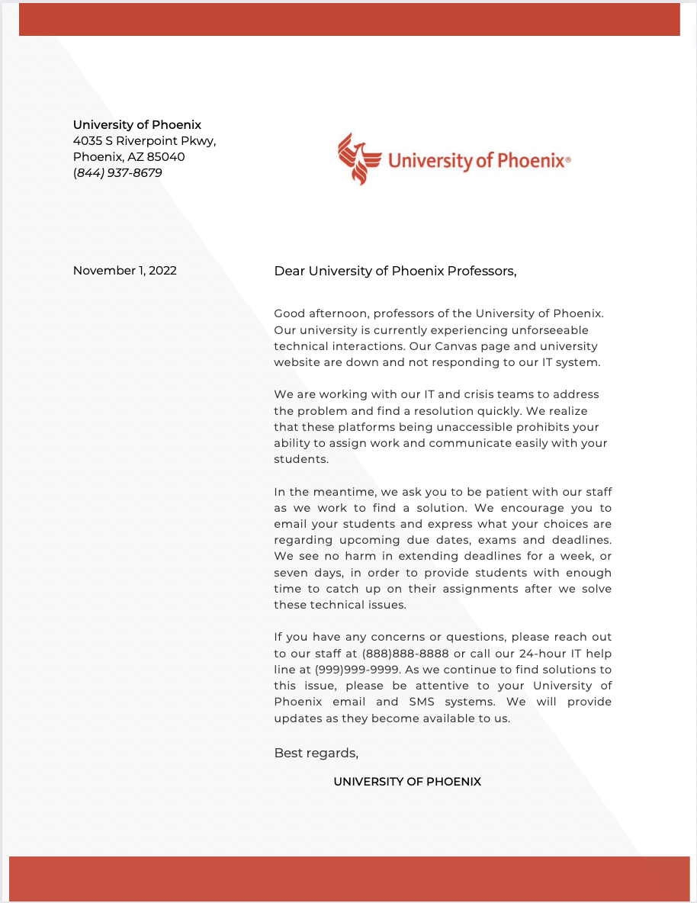
  - Hacking
    - Students of the University of Phoenix
    - Professors at the University of Phoenix
    - Staff at the University of Phoenix
    - Parents / Families of the University of Phoenix students
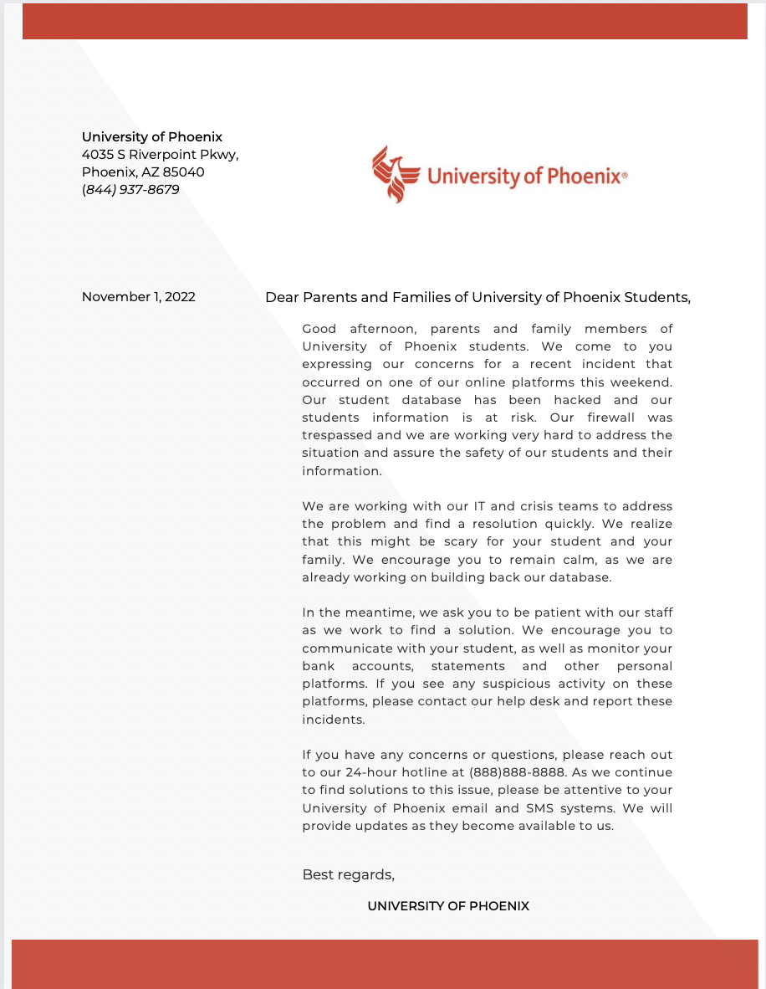
  - Plagiarism / Cheating
    - Students of the University of Phoenix
    - Professors at the University of Phoenix
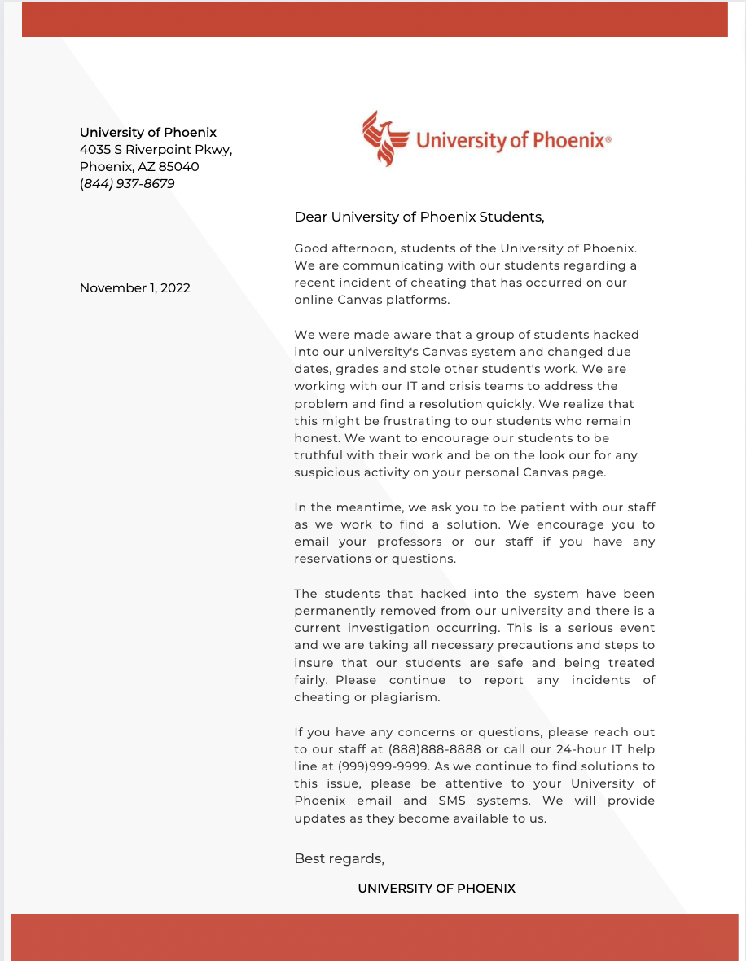

Website
In the event of a crisis, the University of Phoenix will ensure transparency and authenticity with the public. The university will establish any information that may be needed by stakeholders, employees, the media, the public, etc. is available on our website. The website should include consistent updated information about the status of the crisis and what is being done by our university to make corrective action. There should be information about the facts of the event as well as guidance for those who want to get involved or need resources during the crisis. There needs to be a section dedicated to telling the public what we are doing to prevent further incidents from occurring and dictating the status of normal business operations. Statements concerning the facts surrounding the crisis and our response should be placed on the website- whether that be an apology, explanation, etc. We should also upload any statements or conferences we have with the media and continually publish update-statements to keep the public informed.
The website will provide for public feedback by incorporating forums for people to address/discuss their concerns. Staff will monitor the forum to address concerns and/or questions and we will also make posts about frequently-asked questions on other social media platforms. Finally, we will list contact information for members of all affected departments, so people can reach out to them directly if needed.
There may be a need to set up additional sites or pages during a crisis. If there are deaths, we will make a memorial page on Facebook. If there are victims that need to be kept up to date with certain information, we will make a page on Facebook and on our website to keep them informed. There may also be a need to create a parents, students or alumni page on Facebook so different communities can stay informed on crises. Depending on the crisis that occurs, the crisis communication staff will need to determine if other sites or pages need to be created in order to maintain transparency, keep the public informed, and uphold trust in our university.

Social Media
During a crisis situation at the University of Phoenix, social media platforms that should be utilized include, Instagram, Facebook and Twitter. Each of these platforms appeal to both the college-student demographic, as well as parents, staff, professors and other stakeholders of the University of Phoenix.
Content produced on these social media platforms during a crisis should include posts about the initial crisis incident, how the University of Phoenix is addressing and handling the crisis, as well as how students, staff and other stakeholders can protect themselves during the crisis.
Social media content during a crisis should not include any posts that might be taken as insensitive. This could include posts that are fun and exciting, because they would take away from the crisis itself and the University of Phoenix would not look like they are taking the crisis situation seriously. During a crisis, social media should only be used to communicate and post about the crisis.
During a crisis, the social media manager will not be in charge of the account platforms. When a crisis occurs, the crisis team will delegate a specific team- lead by the chief marketing officer, Steve Gross- to work on social media during the crisis. This is because the crisis team will be well versed on the crisis and can handle incoming messages, hatred and other social media tactics that might occur during the situation.
Gross and the social media crisis team will be in charge of responding to messages about the crisis and addressing incoming concerns from the social media platforms throughout the crisis. This means that this individual on the crisis team must be kept up to date on updates and progressions on the crisis.
All regularly scheduled posts should be halted, unless they are of significance to the stakeholders of the University of Phoenix. An appropriate post would include an enrollment reminder, while a post about an upcoming campus event would not be appropriate. Regularly scheduled posts will continue after the crisis has ended and has been properly communicated.

Messages for the News Media During Unforeseeable Technical Interaction Crises
- Points that should be made during the crisis:
During the crisis, stakeholders should be informed of any type of technical issues, as they occur. They should also be informed of what will be done in order to restore the technical assets of the University of Phoenix. The university’s stakeholders should know exactly what changes they can expect, as IT works to fix the problem (ex: class canceled, delayed due dates, etc.).
- What processes did we have in place before this happened?
Backup systems are in place in order to prevent full unaccessibility to the University of Phoenix’s online resources. The university is prepared to release a statement informing University of Phoenix stakeholders of the specific crisis.
- What are we doing or will we do to make this right?
To fix the issues presented by unforeseeable technical interactions, the University of Phoenix executives should work closely with the IT department to find the cause of the issue and how it can be resolved as quickly and efficiently as possible. The university should prioritize communication with its stakeholders throughout the crises, in order that faculty, students and staff of the university are informed and up to date on the current status of the university’s online resources. Multiple updates should be released per day, until the crisis is resolved fully. After the issue is resolved, communication should be released to stakeholders explaining how the University of Phoenix will prevent these issues going forward.
Messages for the News Media During Hacking Crises
- Points that should be made during a crisis:
In the event of hacking, stakeholders should be kept up to date on the situation and how it is being handled. The University of Phoenix should provide information on how stakeholders can protect their accounts and keep watch on any account activity that could be related to the hacking. The university should present stakeholders with any updates as they occur as well as steps being taken to handle the situation and prevent hacking in the future.
B. What processes did we have in place before this happened?
The university has two-factor authentication in place to add a layer of security to their networks. The university also has backup systems in place to prevent the university from losing all access to their resources. The IT department is prepared for how they will take action if the systems were to be hacked.
C. What are we doing or will we do to make this right?
In the event of a hacking situation, the University of Phoenix should prioritize the individual accounts of their stakeholders to ensure the safety of their information. The IT department should then take the necessary steps to regain access to their networks. By providing updated information to stakeholders on the situation, the University of Phoenix will work to reassure stakeholders that the situation is being taken care of to the best of their abilities. Accurate and helpful information will be shared with stakeholders continuously throughout the situation until the problem is resolved.

Messages for the News Media During Cheating and Plagiarism Crises
- Points that should be made during a crisis:
The first priority in the event of a cheating or plagiarism crisis will be to keep stakeholders well informed and up-to-date on all pertinent information, including if and/or how this will affect any classes or schedules. Our message during this crisis needs to be about reinforcing our commitment to honesty and integrity and maintaining the academic validity of the university. It is important to make it known that our fundamental mission is to intellectual growth. It is also necessary to discuss what we will be implementing to ensure trust continues to be placed in the academic integrity of our school.
- What processes did we have in place before this happened?
The University of Phoenix has specific Academic Integrity definitions, expectations and consequences listed in the Student Code of Conduct Handbook. There are also rules and regulations in place to ensure staff and faculty are held to this same standard.
- What are we doing to make this right?
The university will launch a full, impartial investigation into the actions of this event. Any students involved may be given a warning or charge depending on the severity and faculty may be dismissed based on the same grounds. This will be determined based on the investigation's results, the Ethics Committee’s recommendation, and the accused individuals’ responses. We will also work to advocate for academic integrity more on campus and in classes, including requiring an online training course for students, faculty and staff. Finally, the University will be implementing a reporting system within the Ethics Committee, which any student may go to if they feel academic integrity is not being upheld.

Possible Questions and Suggested Responses
In the instance that the University of Phoenix faces any of these three crises at hand, this is a list of possible questions with suggested responses and guidance for the spokesperson/s:
Hacking:
- Media: “how do you think this actually happened?”
Spokesperson: Refrain from any speculation. If facts are not clear, answer with, “I don’t know, we are currently undergoing investigation…” and restate the facts that are known. It is important to be forward with the information that you are presenting.
- Media: “Have any regulations been broken on the university's end that could have resulted in this incident?”
Spokesperson: In this question, it is best to be completely transparent but not expansive on the details. It is suggested that the situation is called just that: a situation until all legal details are figured out. If the statute was compromised then it is best to answer as, “it appears that may have been a possibility, however the situation is under investigation so the actuality is still yet unknown.”
- Media: “Has the University undergone a situation like hacking before?”
Spokesperson: This question has a correct way of addressing, and it is important to remember that framing is key. A suggested response to this question is, “The issue of hacking is not unique within the online world of communication. This is why the University of Phoenix is doing everything in their power to fix this issue and make sure it does not happen in the manner that it did. The University of Phoenix has taken measures that are preventive in nature.”
- Media: “Why did the University not take these measures before?”
Spokesperson: This is a tricky question to answer. A suggested response would look like, “The University of Phoenix prides themselves in taking preventative measures like this, but sometimes those efforts are still compromised. With something as intricate as hacking, this is something that we work every single day to fix and learn new ways to protect our university, as it thrives.”
- Media: “How will the University of Phoenix recover from this?”
Spokesperson: It is key to remain transparent and informational, hitting on three main points. The suggested response should look something like this, “The University of Phoenix is doing everything in their power to investigate this situation so this will not happen again. We are taking this as a learning opportunity and will come back stronger than ever.” It is important to provide instructing information after this initial response.
Plagiarism/Cheating:
- Media: “What do you think happened?”
Spokesperson: Answer the question directly and state what is already known. Refrain from theorizing what could have happened or what we think happened. The suggested response is, “The university does not have a clear indication just yet… and this situation is currently undergoing investigation.”
- Media: “Will the individual/s in question remain on campus as students?”
Spokesperson: “The individual/s in question have been suspended, pending the outcome of the investigation. This is something that the University of Phoenix does not take lightly and will be handled with full precaution.” It is important to address the values that university holds in this statement and to reiterate the process that each student does when taking an exam, quiz or class assignment.
- Media: “How will your procedures change after this incident?”
Spokesperson: It is not best to indicate that the current practices are negligent to the University's efforts. A suggested response will look like “We have no reason to believe our current practices and procedures are an immediate revision, but the university is doing everything in their efforts to identify the causes and make sure it does not happen again.” It is important to never instigate a problem, and remain sympathetic to any staff faults/layoffs or changes due to this situation while remaining transparent to the investigation.
- Media: “Is cheating usually an issue at the University of Phoenix?”
Spokesperson: This question can be tricky to answer as it encompasses a huge concern for online campuses. A suggested response is, “The problem of cheating is not a unique situation in the educational realm. This is why the University of Phoenix has taken preventative measures that require students to enter through a two-system identification form, screen sharing while taking exams and take an anti-plagiarism/cheating course before their second year.” It is crucial for the university to inform the reporter on the procedures that the university puts in place to prevent cheating/plagiarism
- Media: “How does the university feel knowing that they will not catch every single person who cheats?”
Spokesperson: A question like this is tough to answer, but with the right response it can be handled correctly. A preferred response will look something like “The University of Phoenix still does everything in their power to make sure this does not happen, despite this fact. While this is something that cannot be 100% fool proof, we take these matters very seriously and have multiple systems in place to be as authentic and encourage that our students are doing so as well.” It is important that the university falls back on its values in this statement and remains transparent with the fact that this is not always preventable. Sticking to the facts and reiterating the systems in place is the best way to answer this question.
Unforeseeable Technical Interactions:
- Media : “How will this unforeseen technical interaction with the schools main open-source learning platform affect students' learning ability?”
Spokesperson: This question can be asked in various ways, but still calls for the same response. The suggested response should remain sensitive to the issue and students' ability to access their online education, as well as offer instructing information. The response should look like, “We are working diligently in finding out the main cause of this situation and fixing it in a manner that will allow students to access their learning platform. We believe this situation will not affect our students' learning ability long-term and we are in direct communication with our community and as to how we can assist them during this situation.”
- Media: “How will your technical procedures change after this incident?”
Spokesperson: It is important to refrain from indicating that the current practices are neglectful in any manner. The suggested response should look something like, “We have no reason to believe our practices are in need of revision. Every experience is a learning experience, and regardless of what comes to fruition, we will use this as an opportunity to grow.” It is important to be sympathetic to the public's opinion, but to restate and stick to the facts as they are.
- Media: “How much damage was sustained from this incident?”
Spokesperson: Do not try to estimate the damage in dollar amount. It is instead suggested to reiterate that the situation is undergoing investigation and the direct damage will not be exceptional. A suggested response is, “The university currently has no reason to believe that the damages from this situation will be substantial.”
- Media: “ Will this incident affect the university’s online presence?”
Spokesperson: Address this question in a manner that highlights the university’s reputation as an online program. The suggested response should look like “The university of Phoenix takes pride in its accomplishment as a reputable university. We believe this incident does not reflect the university’s success as an online campus.”
- Media: “Has the University of Phoenix seen an incident like this before?”
Spokesperson: It is important to be honest in this question. Remaining transparent and forthcoming with information is the correct response. The suggested comment to this answer should be, “Technical interactions within an online campus is not something that the university has never seen before. This is why the University of Phoenix has safety measures put in place with a protection program for all of its students.”

It is extremely crucial that each spokesperson refrain from using the phrase “no comment” or anything that indicates a lack of cooperation. Using the phrase “no comment” suggests to the public that the organization is hiding or withholding information. Avoiding this phrase is done to show that the university is remaining transparent, honest and cooperative throughout the process. When the media is confronted with a statement as such, this encourages them to pry harder to get more information, so it is suggested that the spokesperson remain transparent. If the answer to the question is still unknown, say just that: “I do not know” or “I will get back to you on that question pending investigation.” While the spokesperson has every right to withhold commenting on a subject, the proper response should be, “The case is still under litigation and, therefore I am unable to comment on it currently.” It is important to stick to the facts that are presented and reiterate the university’s values and stance on the incident when approached by a question that does not need to be answered.

Pre Gathered Information
- Unforeseeable Technical Interactions
  - Unforeseeable technical interactions can affect the university deeply, seeing that the majority of the University of Phoenix’s courses are held online. The chance that technology might have any issues, could lead to classes being canceled or delayed due to technical assets being inaccessible.
- Hacking
  - Hacking is very dangerous to the University of Phoenix. This is a major concern because the university houses thousands of students' information in their databases. If firewalls are trespassed, there is a chance that personal information can be released to the world. Hacking puts students, faculty and staff in major danger.
- Cheating / Plagiarism
  - Cheating and plagiarism are very serious issues that the University of Phoenix must overcome. Students' work is in jeopardy if another student decides to claim said work as his / her own. Cheating and plagiarism puts an unfair advantage into the mix for students. The University of Phoenix prioritizes those students whose work falls victim to plagiarism and cheating. The utmost priority is protecting students' work and their assets, so that each student is receiving equal treatment.

URLs for Resources
Federal Trade Commission: consumer advice https://consumer.ftc.gov/articles/how-recover-your-hacked-email-or-social-media-account
- How to recover a hacked email or social media account
- What to do after you get back into your account
- How to protect your account in the future
EDU Is https://eduisonline.com.ng/six-tips-to-protect-your-school-from-hackers/
- What is hacking
- Different types of hacking
- How students can take safety measures
Cyber and Infrastructure Security Agency https://www.cisa.gov/cybersecurity
- Cybersecurity services
- CISA’s role in cybersecurity
- How to combat cyber crime
Cyber and Infrastructure Security Agency https://www.cisa.gov/cyber-incident-response
- Incident response training
- Cybersecurity Incident and Vulnerability response playbook
- How to report a cyber incident
Security https://www.security.org/antivirus/hackers/
- How antivirus works
- Top antivirus softwares
- What to look for in antivirus protection plans

Grammarly https://www.grammarly.com/plagiarism-checker?q=plagiarism&utm_source=google&utm_medium=cpc&utm_campaign=1572890383&utm_content=453386138605&utm_term=plagiarism%20checker&matchtype=b&placement=&network=g&gclid=Cj0KCQiA99ybBhD9ARIsALvZavXiTv37TAYO44LarAF924vT4JEf_DOts99xHR7nUrYcac9HVPg_b_QaAv2vEALw_wcB&gclsrc=aw.ds
- Checks for plagiarism on essays
- Shows preventative plagiarism methods

Evaluation of Plan Effectiveness After a Crisis
- Steps to ensure better preparedness for next crisis:
To ensure better preparedness for future crises, the University of Phoenix will review and update its crisis communication plan every year. During this revision, a crisis communication team will be set and each member will be alerted of his or her responsibilities. The university will also develop dark sites that are ready to go up in the event of certain crises. The school will work with the upper-level communications classes to re-asses and gain a new perspective on the crisis plan. This will allow the students to gain real work experience and knowledge that works towards better preparedness for the entire university. Finally, we will consistently work to maintain good, effective communication with media outlets, including the student paper and local news sources.
- What areas of your CCP will be evaluated? (e.g., social media, media relations, community relations, etc.)
Each year, the review will include a new evaluation of the most likely crises to ensure we have relevant and updated responses for each. We will also evaluate the crisis communication team and look for different, more effective ways of communication within that team. Media and community relations will be evaluated to ensure effective communication and good relationships are maintained even when there is no crisis at hand. We will also require each member of the crisis communication team to sign off on each part of the CCP to ensure anything that needs updating will be updated and that everyone is on the same page.
- Evaluation Form to use at the end of a crisis:
  - This will be distributed to each member of the crisis communication team as well as any member of any other internal departments that were involved in aiding with the crisis procedure.
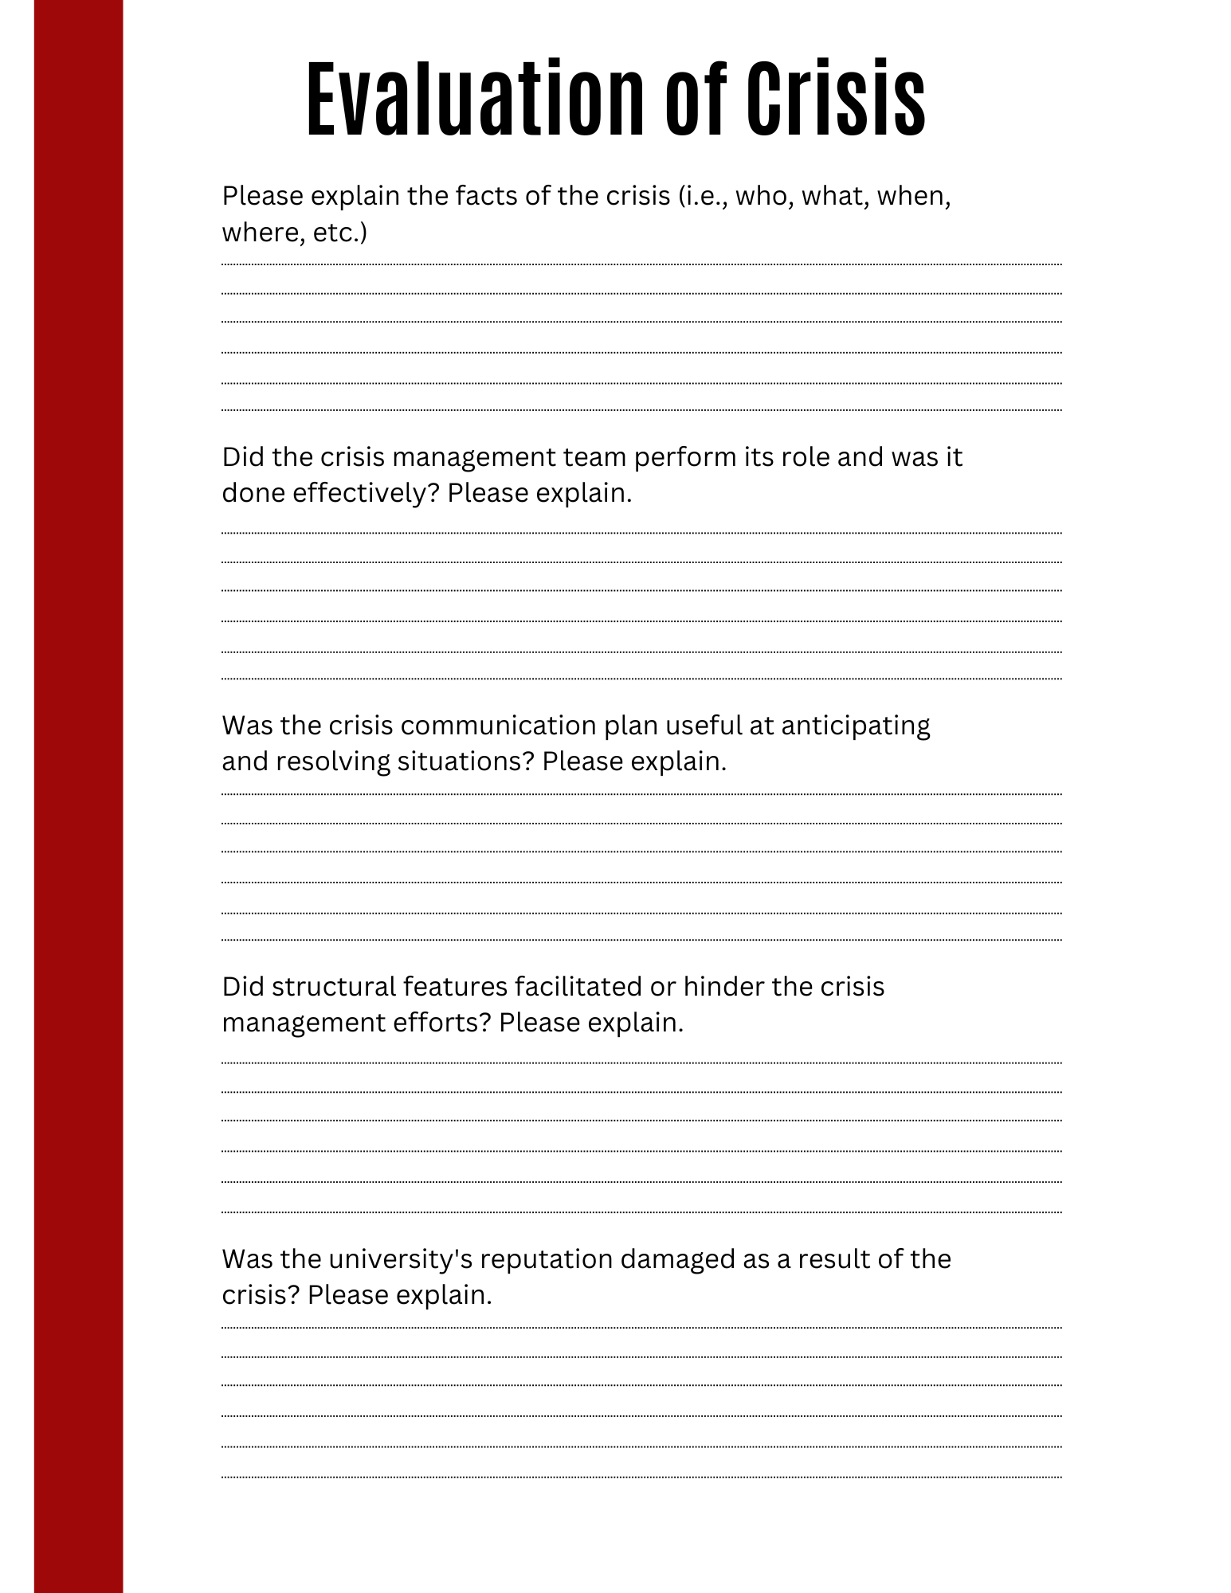

References
Arie, K. (2007, November 26) Blackboard's shutdown statewide. The Utah Statesman. Retrieved September 29, 2022, from https://usustatesman.com/blackboards-shutdown-statewide/
Console, R. (2022). Marymount Manhattan College reports data breach following unauthorized access to the school's network. JD Supra. https://www.jdsupra.com/legalnews/marymount-manhattan-college-reports-9362959/#:~:text=In%20most%20cases%2C%20college%20data%20breaches%20are%20the,or%20sell%20to%20others%20on%20the%20dark%20web.
Rogers, D. (2015). University of Phoenix settles lawsuit to continue to protect academic integrity. Business Administration Information. https://www.businessadministrationinformation.com/news/university-of-phoenix-settles-lawsuit-to-continue-to-protect-academic-integrity

Robert M. Weiler (1998) Developing Fact Sheets, Journal of Health Education, 29:1, 46-50, DOI: 10.1080/10556699.1998.10603301

